echo "Enter Number 1"

read num1

echo "Enter Number 2"

read num2

if [ $num1 -gt $num2 ]

then

    echo $num1

else

    echo $num2

fi

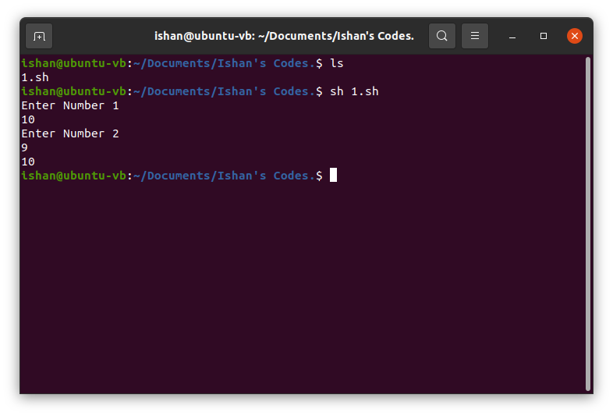

for i in $(seq 1 1 10)

do

    echo $i

done

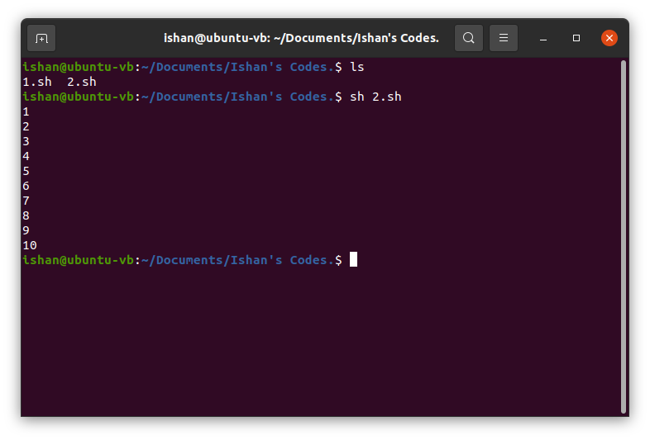

echo Enter Number :

read n

echo Factorial :

fact=1

i=1

while [ $i -le $n ]

do

fact=`expr $fact \\* $i`

i=`expr $i + 1`

done

echo $fact

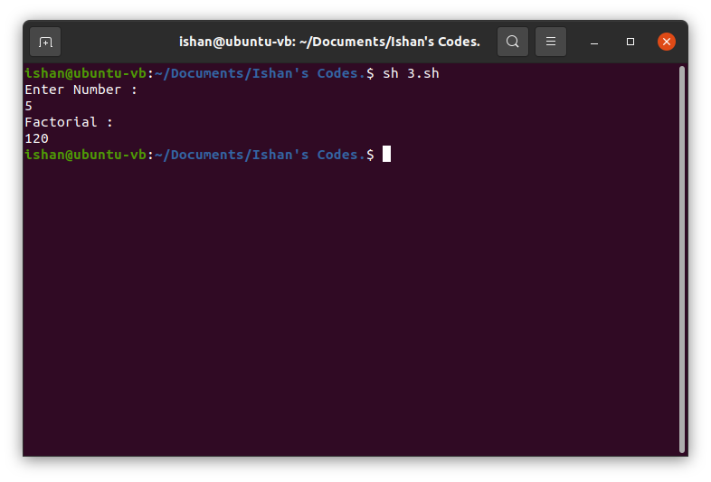

echo Enter Number :

read n

i=1

for i in $(seq 1 1 10)

do

    echo `expr $n \\* $i`

done

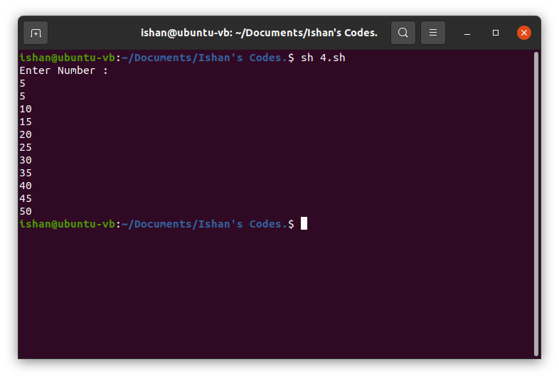

echo Enter lower and upper

read m n

for a in $(seq $m $n)

do

    k=0

    for i in $(seq 2 $(expr $a - 1))

    do

        if [ $(expr $a % $i) -eq 0 ]

        then

            k=1

            break

        fi

    done

    if [ $k -eq 0 ]

    then

    echo $a

    fi

done

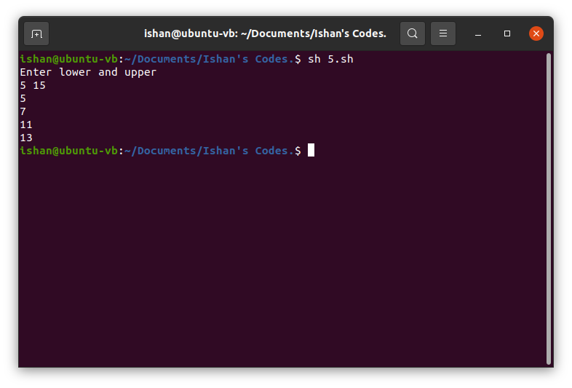

echo "Enter a number"

read num

sum=0

while [ $num -gt 0 ]

do

    mod=$((num % 10))

    sum=$((sum + mod))

    num=$((num / 10))

done

echo $sum

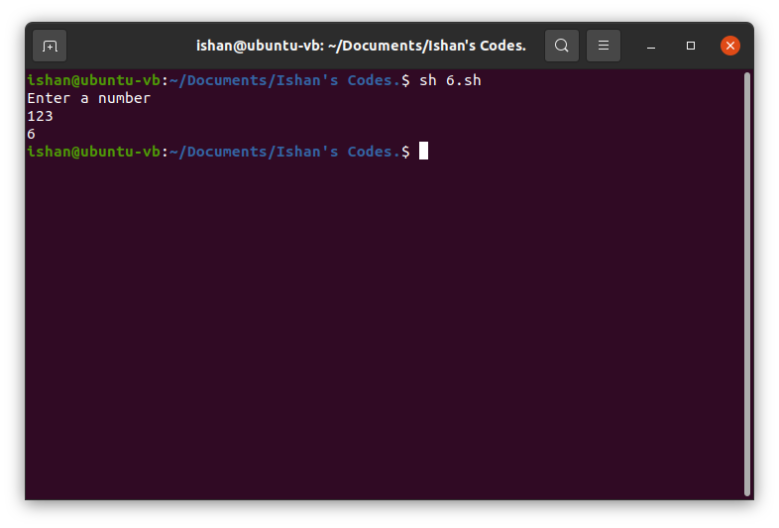

echo "Enter a Sentence"

read text

word=$(echo -n "$text" | wc -w)

echo $word

